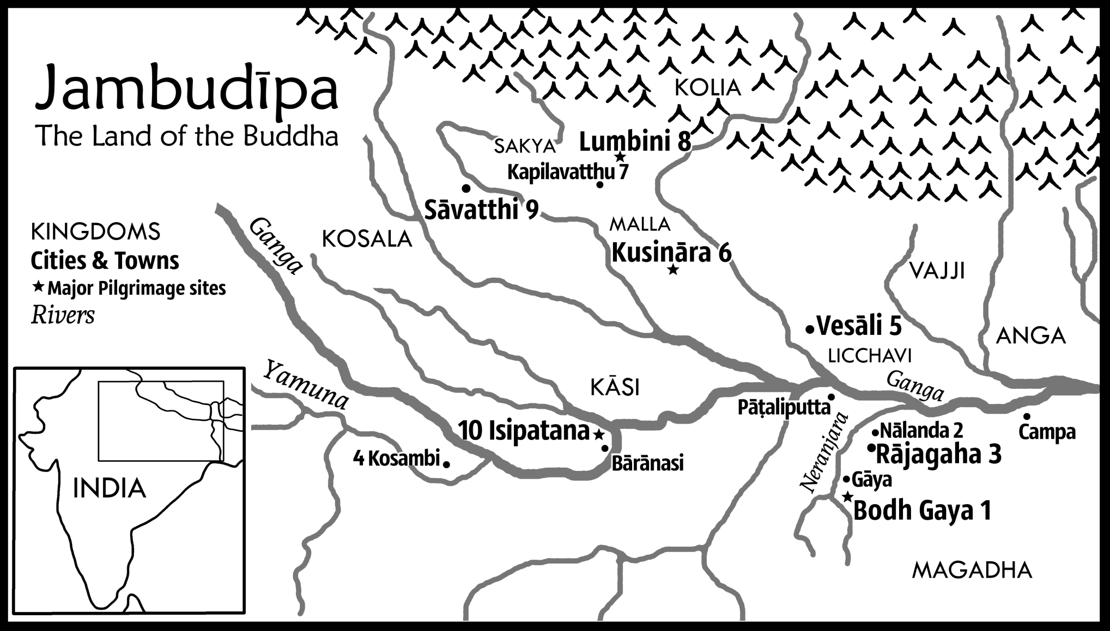
1 | ★Bodh-gaya (Buddha-gaya) | Place of Enlightenment (Maha-Bodhi Temple)
2 | Nālanda | Headquarters of the rival Niganthas
3 | Rajagaha (Rajgir) | Vulture’s peak mountain; Home of King Bimbisara
4 | Kosambi | Site of a famous dispute
5 | Vesāli (Vaishali) | Original location of a portion of the bone relics
6 | ★Kusinara (Kushinagara) | Buddha’s Final Passing away
7 | Kapilavatthu (Kapilavastu) | The Buddha’s home town; Original location of a portion of the bone relics
8 | ★Lumbini | Birth place
9 | Savatti (Shravasti) | Main teaching monastery; Ānanda Bodhi Tree
10 | ★Isipatana, Deer Park (Sarnath, Migadāyā) | Site of first and second sermon

