Namo Buddhaya
The most sacred places in Sri lanka

Ruwanvelisaya-Anuradapura  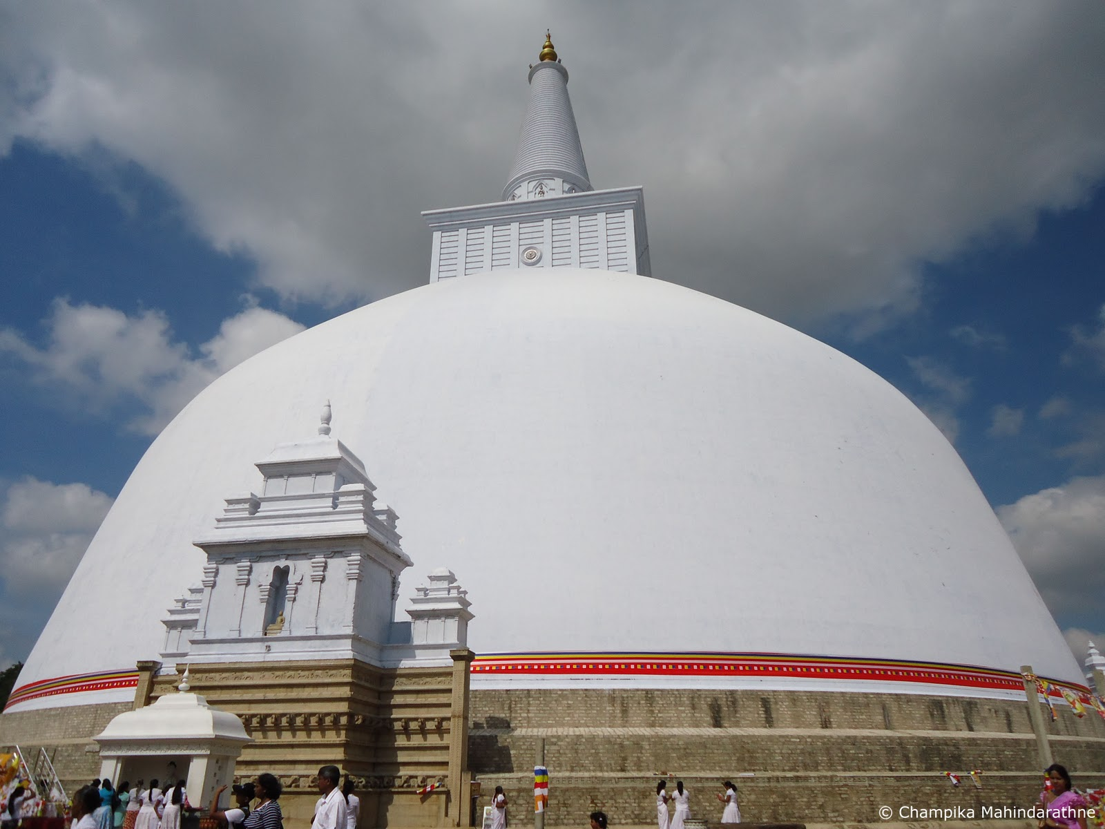  This is Ruwanvelisaya Stupa in Anuradhapura, Sri Lanka. It is the tallest stupa and contains the most relics in one place. This makes it very special. It contains 1 of 8 relics of Buddha. Great king Dutu Gamunu built this wonderful stupa. Lots of good people went to heavenly world by worshiping and offering flowers,etc... to this stupa. Let us also collect great merit by paying homage to this stupa.  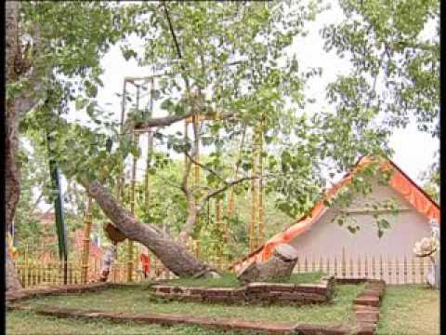  Jaya Sri Maha Bodiya  Prince Siddhartha became Buddha under the Bodhi tree in India on vesak full moon poya day. Under the bodhi tree he became the greatest person in the world. The Shri Maha Bodhi tree in Anuradhapura, has grown from the cutting brought from India by the Arahant Nun Sanghamitta. And this is the one and only branch of The original Bodhi tree in the world. we are very fortunate to have it in our country. This venerable Bodhi tree is being worshiped by millions of people and gods. Lets pay homage to Jaya Sri Maha Bodhi tree and collect lots of merit to our life. | 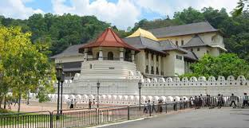  Dalada maligawa-Kandy  The most sacred relic on the island is the holy tooth relic of the Supreme Buddha. The relic is the tooth on the left side of lower jaw of Buddha. It is held in an ancient royal palace in the structure you can see with the golden-colored roof. The sacred tooth relic is now placed in seven golden caskets. It's brought out only during special public viewing days held once every couple of years. Princess Hemamala and her husband prince Dantha brought it to Sri Lanka from Kalinga in India. Lets us also worship the sacred tooth relic along with millions of gods and humans.  Sri Padaya  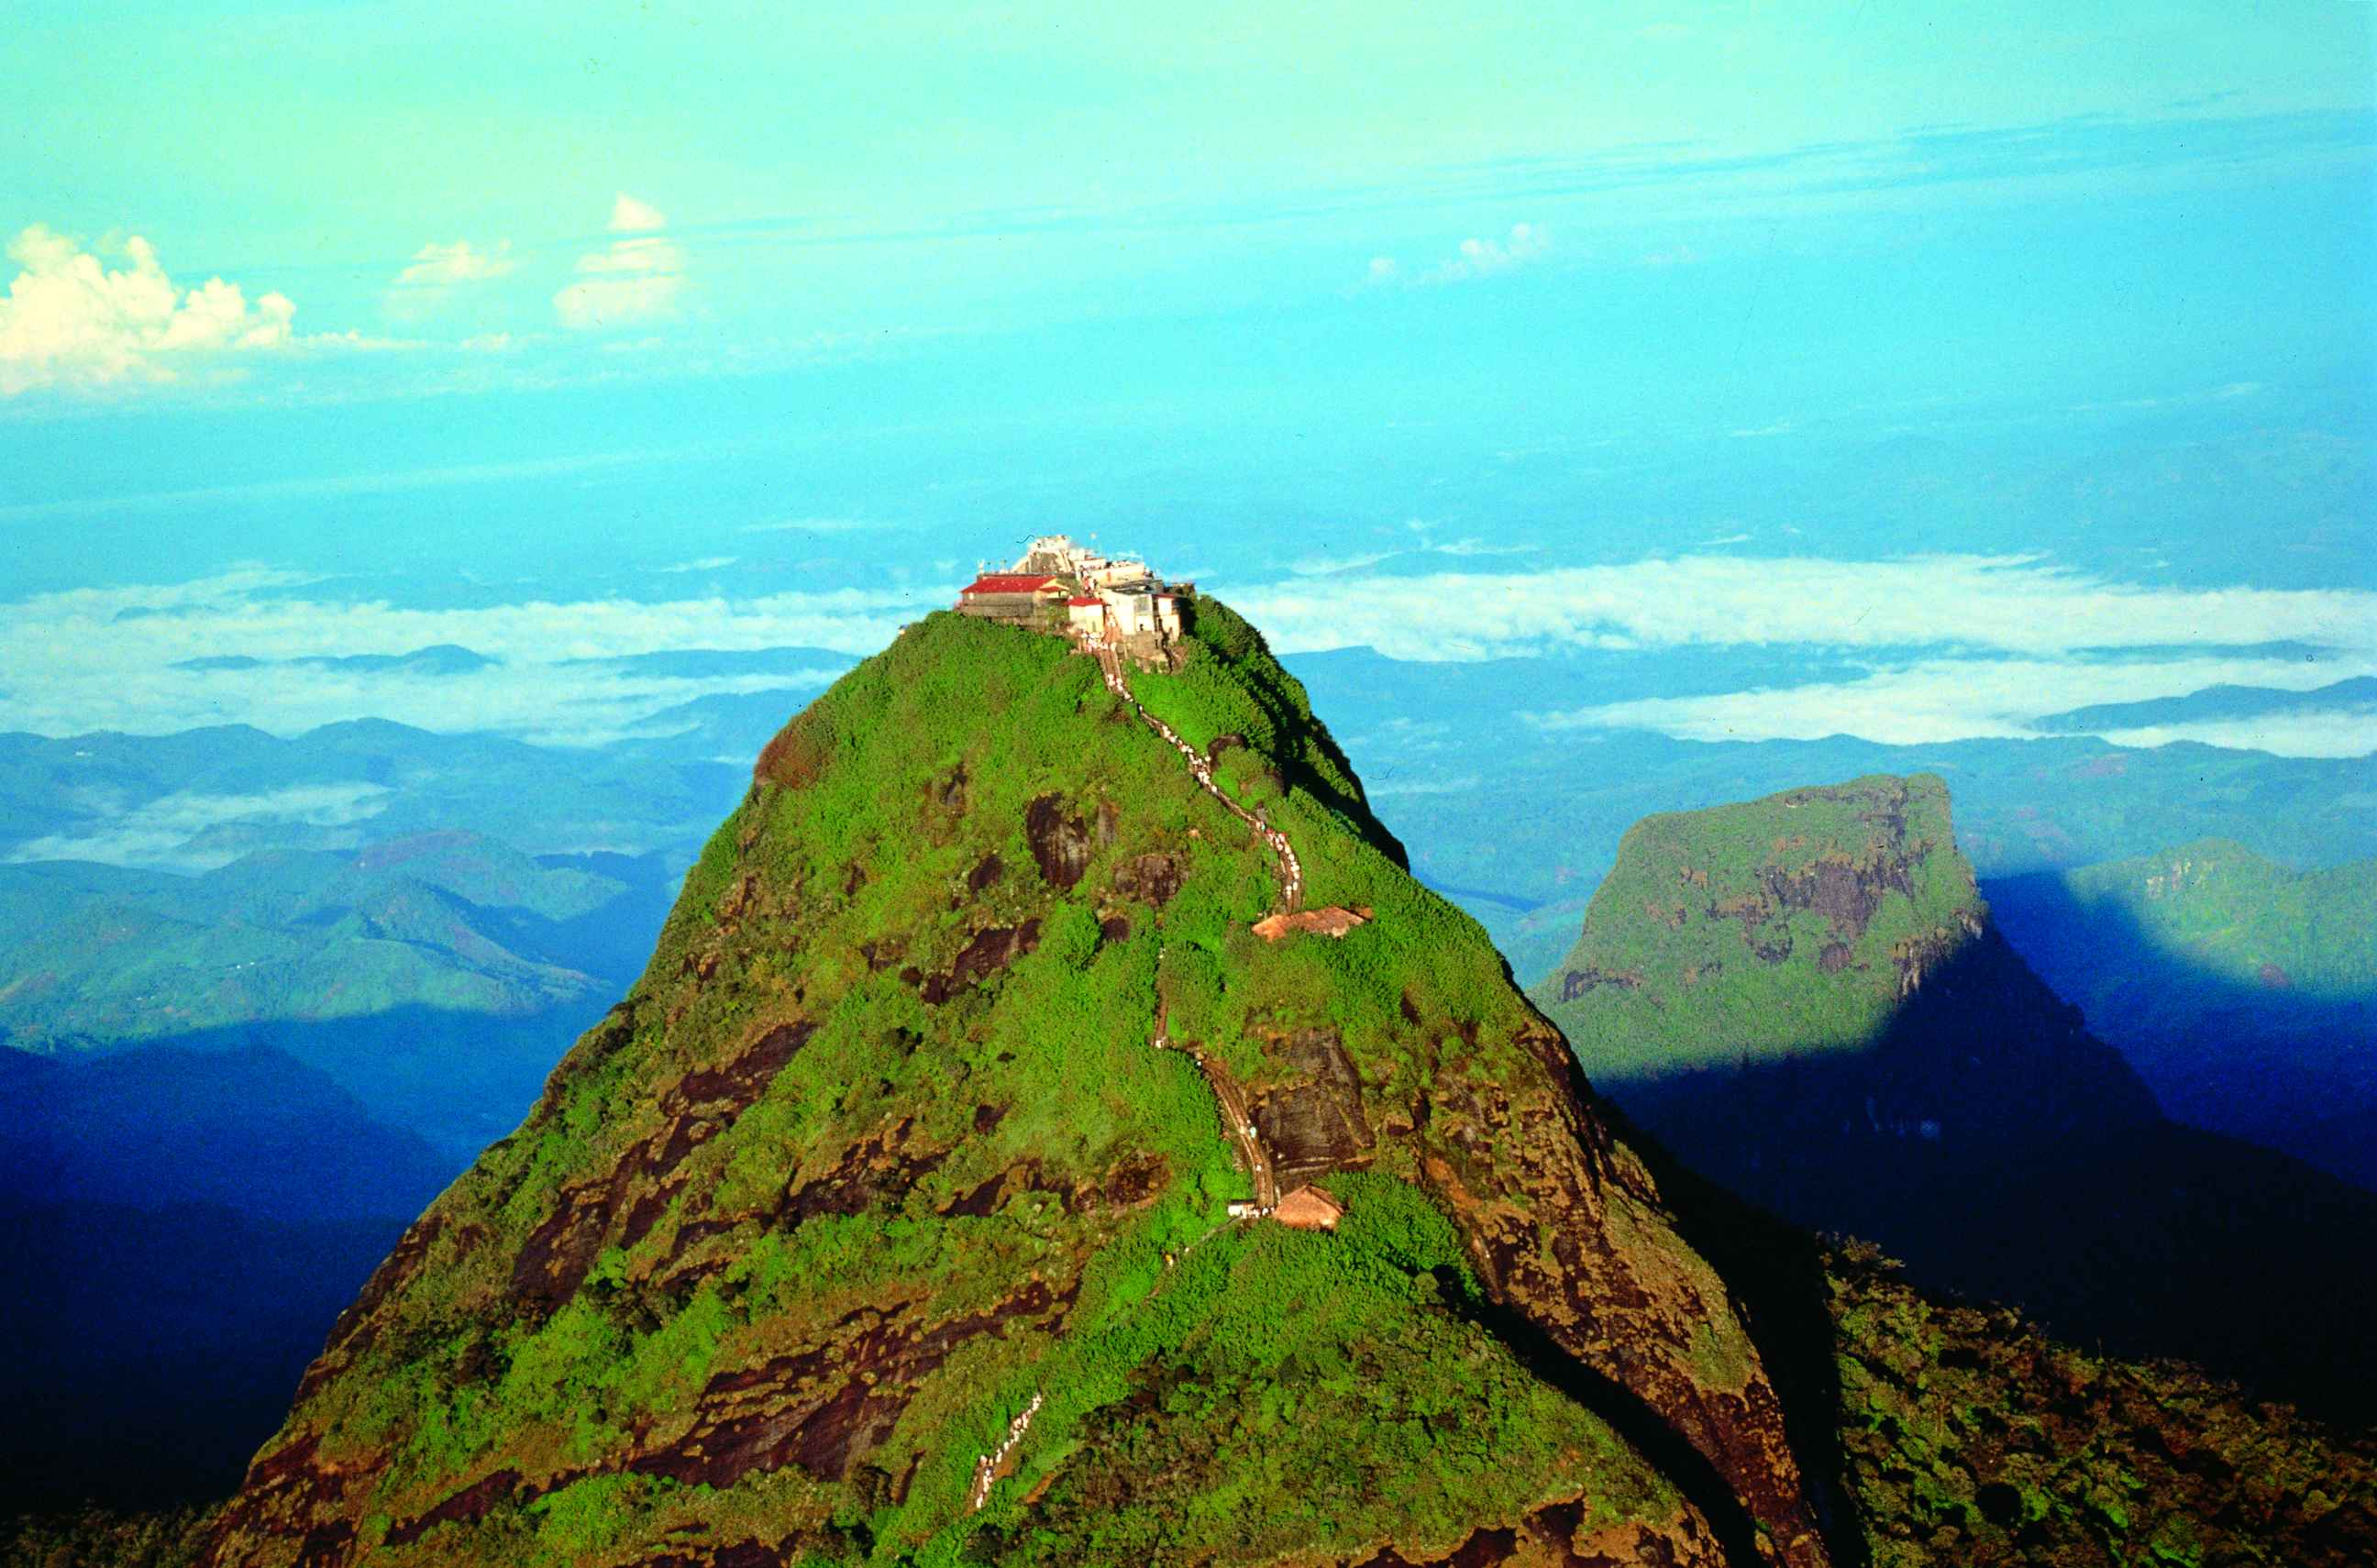  This is Sri Pada. At the top of the mountain is a footprint in stone left by the Buddha on one of his visits to Sri Lanka. The god that inhabited Sri padaya is god Sumana Saman. After listening to the teachings of Buddha he became a follower of Buddha and invited Buddha to his mountain. When Buddha visited Sri Padaya god Sumana asked Buddha for something sacred so he could worship. Then Buddha imprinted his footprint on a gemstone using his special powers. May our humble homage to the sacred footprint of Buddha.
Thuparamaya-Anuradapura  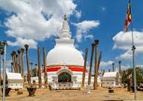  At the request of Arahant Mahinda,who brought Buddhism to the island, King Devanampiyatissa (250BC – 210BC)built Thuparamaya to hold the collarbone relic of the Buddha. This is the first stupa to be built in the country after the introduction of Buddhism to Sri Lanka. In the image you can see how the pillars once supported a structure surrounding the stupa. Let us pay our homage to this sacred stupa as well.  Mihinthalaya  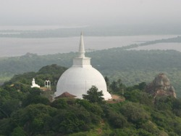  Venerable arahant Mahinda brought Buddhism to Sri Lanka. He came to the country in the air using his special powers. And this is where he landed first in the island. While king Devanampiya Thissa was hunting on this Mihintalaya mountain the king met arahanth Mahinda. After listening to the teachings of Buddha the king became a disciple and helpd spread Dhamma in Sri Lanka. There are three sacred stupas in this site. Since this is Where Buddhism started in Sri Lanka, all Buddhists in the country respect this sacred place. |  | Mahiyangana Stupa  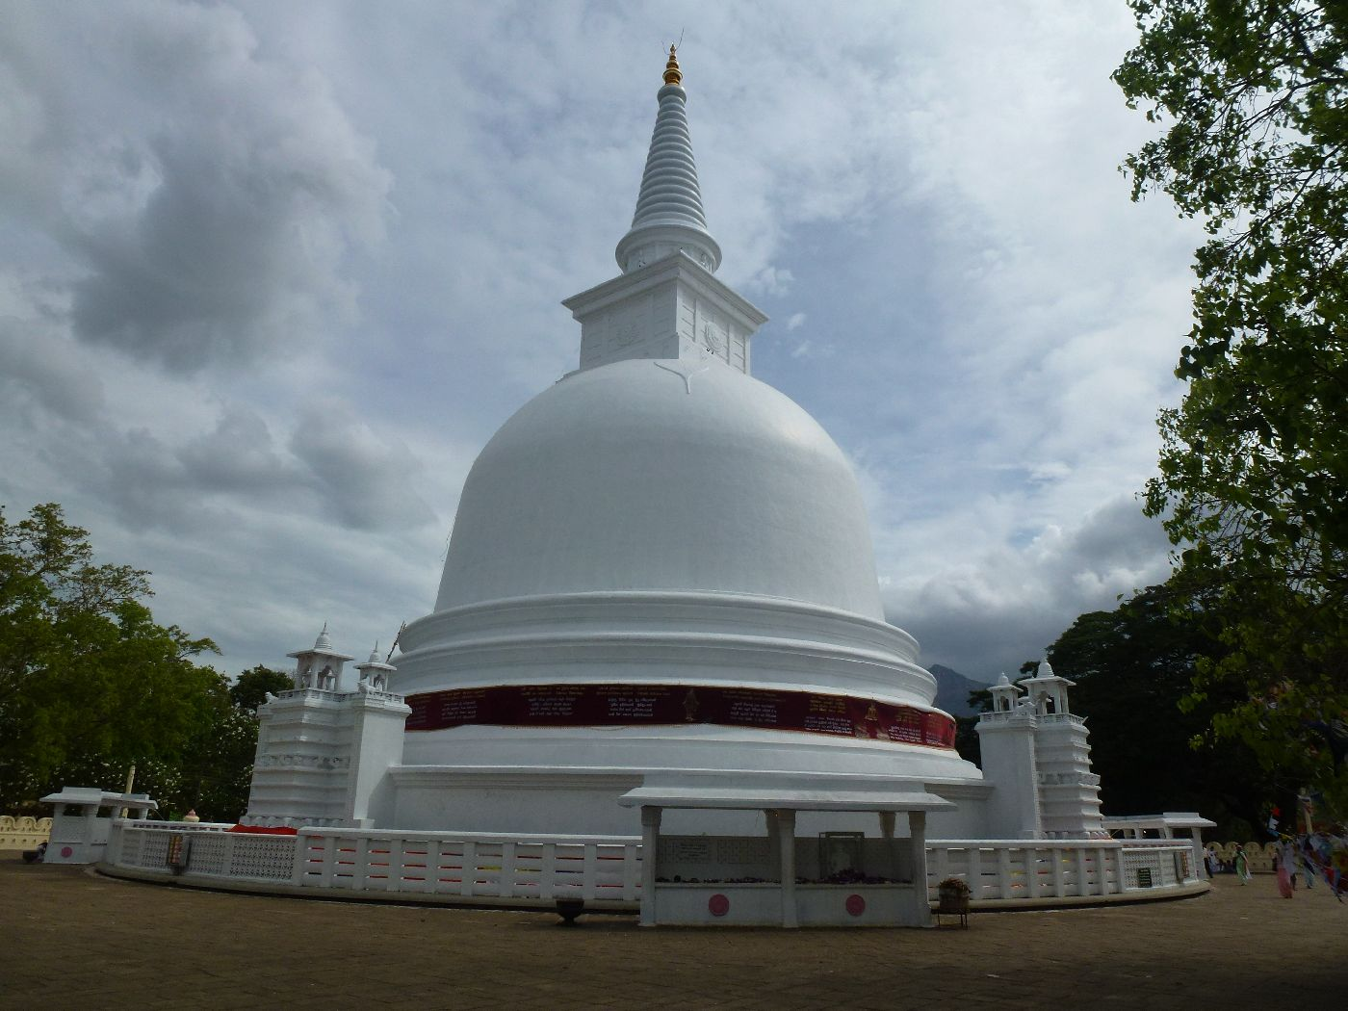  After nine months of attaining enlightenment, Buddha visited this exact place for the first time. At that time the country was inhabited by very aggressive demons. Buddha tamed these demons and made the country inhabitable by humans. This magnificent stupa holds Buddha's sacred neck bone relic(Greeva dhatu) and some sacred hair relics.  Nagadeepaya  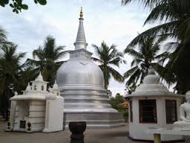  Buddha came to Nagadeepaya to settle a conflict over a gem throne between two naga kings in his second visit to the country. This stupa contains that gem studded throne.  Kalaniya Stupa  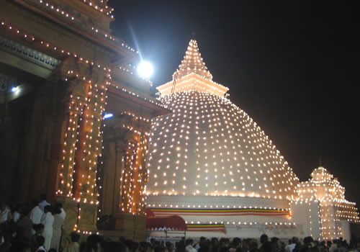  Buddha visited this place in his third visit to the country. Buddha preached dhamma to naga king Maniakkhitha sitting on a gem throne at this place. This sacred stupa contains that sacred gem throne.

