Mahamevnawa Auckland

Dhamma School

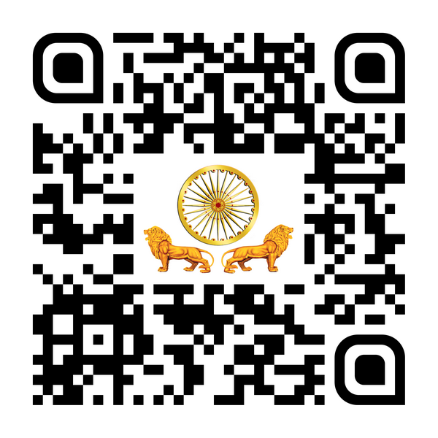

Register Online

Now

Or visit

buddhistauckland.org/dhamma-school